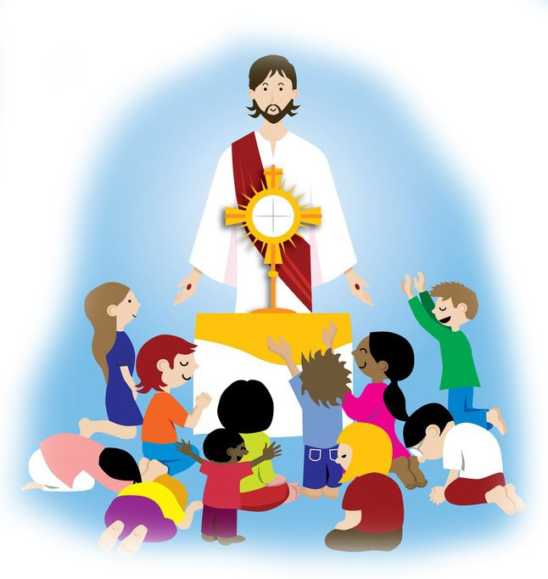
“Let the children come to me.”
- Matthew 19:14

Eucharistic Holy Hour for Children Pre-K through 4th grade

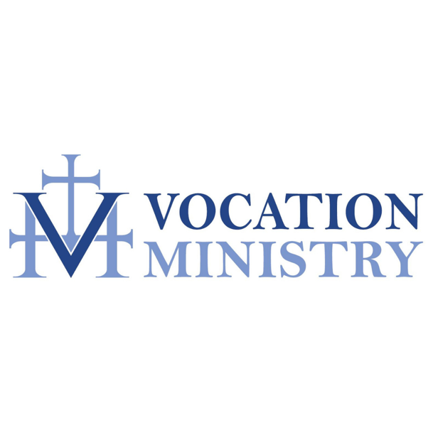
Children must be accompanied by parent

