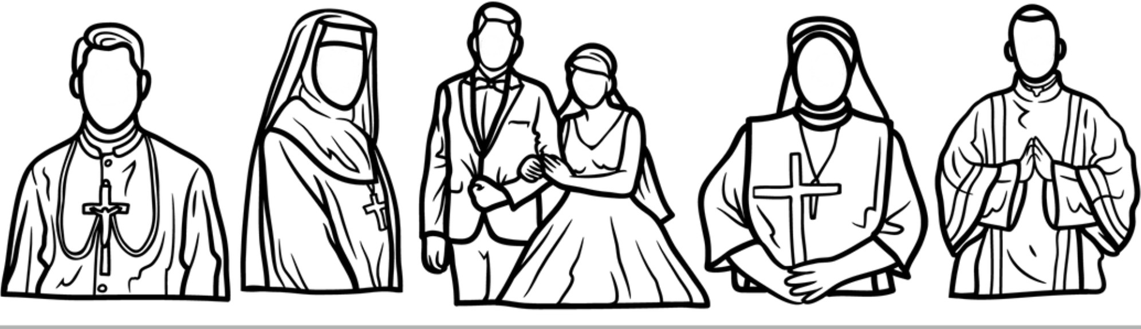

**NATIONAL VOCATION AWARENESS WEEK**

*"If you are what you should be, you will set the world ablaze!"*

*-St. Catherine of Siena*

**Dear Parish Ministry Leader,**

With great joy, we invite you to join us in celebrating the National Vocation Awareness Week from [date] to [date]. This special time is an opportunity for our entire parish family to unite in promoting and praying for vocations to the Priesthood, Consecrated Life, and Diaconate.

As St. John Paul II beautifully said, "The family is the seedbed of vocations." Let us ensure that the message of vocations resonates wherever families gather in faith, fostering a culture of prayer and support for all to discern how God is calling them to serve and love Him. Your involvement can make a profound difference in nurturing vocations within our parish community.

All parish ministries and organizations are invited to participate by incorporating this theme of vocation awareness into your November activities. Here are some ways to help you get started:

* Begin your meetings with a prayer for an increase in vocations to the Priesthood, Consecrated Life, and Diaconate, especially from our parish.
* Pray the Rosary together for this intention.
* Attend Eucharistic Adoration as a group to lift up this important cause in prayer.
* Ask members to offer this intention at daily and Sunday Masses.
* Write notes of support to our seminarians and those discerning their vocation.
* Nurture relationships with youth and young adults, encouraging them to ask God about His plan for their lives.

Please share with our ministry liaison [Name] at [Email address] by [Date]  how your group plans to participate. We understand that scheduling can be a challenge, so feel free to adjust the timing as needed. Our goal is to foster a culture of constant prayer for vocations, not just during this week, but always.

Thank you for your dedication to our parish community. Together, let’s build a future full of joyful, faith-filled vocations!

In Christ,

[Your Name]  
[Your Position]